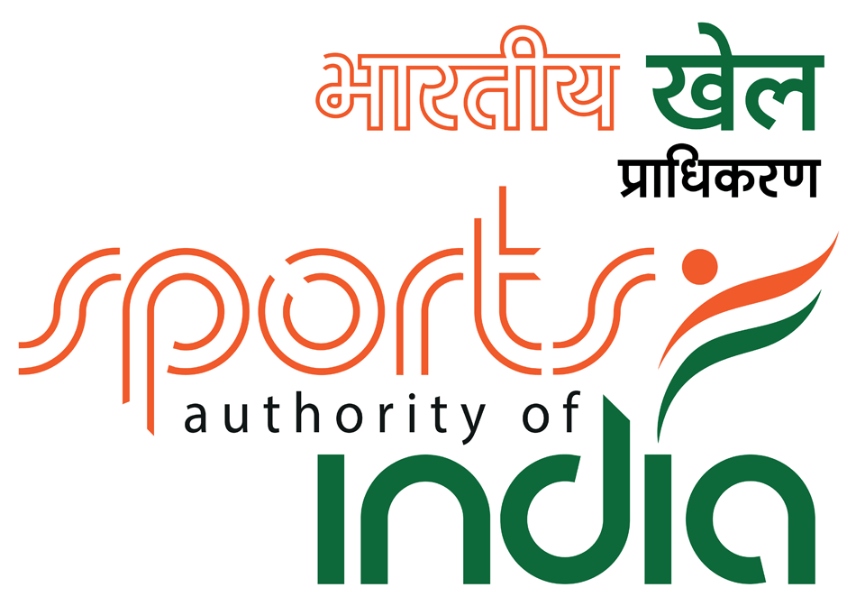

8th NATIONAL SCHOOL CHESS CHAMPIONSHIPS - 2019
FIDE Rated event

(AICF Event code no:208632/208633/208634/208635/208636/208637/208638/208639/208640/208641/208642/208643/Cha/2019)

3rd April to 7th April 2019

On behalf of

ALL INDIA CHESS FEDERATION
Under the Aegis of
Chhattisgarh Pradesh Chess Association
Organized by

Raipur District Chess Association
Venue

AgrasenDham,Near 36 city mall G.E Road
Raipur,Chhattisgarh

1. Invitation:

Raipur District Chess Association on behalf of All India Chess Federation (AICF), have the honour to invite all the State Associations* (any Syllabus) in India to participate in the 8thNationalSchool Chess Championships-2019 (Under-7, Under-9, Under-11, Under-13, Under-15 & Under-17 for Open & Girl’s categories) to be held at AgrasenDham,Near 36 city mall G.E Road Raipur,Chhattisgarh

2. Schedule:Individual Championship

Registration at the Venue | 02nd April 2019 | 09:00 A.M to 09:00 P.M.
Inauguration / Managers meeting | 03rd April 2019 | 09:00 A.M.
Round – I | 03rd April 2019 | 10:30 A.M.
Round – II | 03rd April 2019 | 04:00 P.M.
Round – III | 04th April 2019 | 09:00 A.M.
Round – IV | 04th April 2019 | 02:30 P.M.
Round – V | 05th April 2019 | 09:00 A.M.
Round - VI | 05th April 2019 | 02:30 P.M.
Round - VII | 06th April 2019 | 09:00 A.M.
Round - VIII | 06th April 2019 | 02:30 P.M.
Round – IX | 07th April 2019 | 09:00 A.M.
Prize Distribution | 07th April 2019 | 03:00 P.M.

3. Eligibility for Participation:

Only Individuals who are school students and who are Indian Nationals are eligible to participate in this Championship. Players who are foreign nationals and who have PIO or OCI card cannot participate.

- * Entries approved by the concerned state chess association are alone will be paired.

- Each State Association may enter any number of players in each of the 12 age groups. The player should be a bona-fide student of a school (anysyllabus). In case that one girl group is less than 10 participants then it will be merged with the same open age group category.

- Entitled to participate are players (Boys & Girls) who shall not have reached the age of 7,9,11,13,15,17 before 1 January, 2019.

- Under 07:Born on or after 1 January, 2012;

- Under 09: Born on or after 1 January, 2010;
- Under 11: Born on or after 1 January, 2008;

- Under 13: Born on or after 1 January, 2006;
- Under 15: Born on or after 1 January,2004;

- Under 17: Born on or after 1 January, 2002;

- **Since there is no separate National School Chess Championship for under 5, players for the Under 5 Asian School Chess Championship 2019, will be identified as per rankings from among the participants in the National School under 7 Chess Championship 2019 subject to their age. Therefore, those planning to participate in the Asian Youth Under - 5 - 2019 (if held) should participate in the National School Under - 7 Chess Championship 2019 to be eligible for consideration.

4. Age Proof: Each participant must produce a valid certificate to prove his / her age. Certificates fromSchool are not enough. Certificates should preferably be from the Panchayat, Municipality or Corporation obtained soon after birth. Players without date of birth certificates will not be allowed to participate.

The date of birth certificates registered within one year of the birth of the child alone will be recognized and allowed to participate. No state association shall recommend any player who doesn’t come under the above criteria.

If any doubt arises about the claimed age of a player, the Tournament Committee has the right to refer the player during the championship for a due evaluation of age by competent medical experts. A player if declared over-age by such experts shall not continue in the championship and the matter shall be reported to AICF. Protest about the age of players may be made to the Chief Arbiter in writing along with a fee of Rs.5000/- per player. This will not be refunded. No Protest about over age of a player will be entertained after 2ndround of the championship.

Only the Coach or Manager deputed by participating State Chess Association can lodge such protests. The Tournament Committee has the right to decide the day, time and place for such medical evaluation of age. AICF / Organizers will have the right to refer any player to the medical evaluation of age at any time during the Championship. Players refusing to take the test as decided by the Tournament Committee shall be deemed to have failed the test and shall be disqualified from the Championship.

5. Dress Code: As per AICF regulations on Dress Code for players participating in all the Nationalchampionships, all State Associations should send their players including special / donor entry players with proper uniform (As regards special / donor entry players, the respective State chess associations may collect the cost of the uniform from the players).

Players should at least wear uniform T Shirts / formal shirts (same color and brand with the name of the State printed prominently at the back and the state chess emblem in the front left side). The name / logo of the sponsors can be permitted. The girls / women are also given appropriate uniform dress. The above rule will also be applicable to Special units. Players without proper uniform will not be permitted to take part in the championship. This will be strictly enforced.

6. Accommodation:
Players have to make their own arrangement for their stay during the event. Limited accommodation (Dormitory / Furnished) is available at nominal cost on the first come first serve basis. http://www.cgchess.com

Rules of booking:
1. 3 BEDDED ROOM- MAX only 4 persons are allowed.
2. Cooking is strictly prohibited inside the premises and rooms
3. Consumption of Non Veg eatables inside the premises is strictly prohibited and is subject to termination from the tournament.
4. Consumption of alcohol and tobacco of any kind is strictly prohibited and will draw monetary penal action and termination from the tournament.
5. Rights of admission in the premises lie with the organisers.

6. Any damage to the property will be assessed by the property owner and will have to be paid by the occupant of the room.

7.Check in will be allowed after 11.00am on 2nd April and Check out will 08.00 am on 8th April 2019

8. Occupants will be responsible for their own belongings. In any way the organizers are not responsible for any loss or damage incurred to the occupants.

9. Gambling is strictly prohibited and unlawful and will attract lawful actions and termination.

Cancellation fee& Refund
1. 25 % if cancelled before 60 days of the tournament.
2. 50% if cancelled before 30 days.
3. 75% if cancelled before 15 days.
4. No refund if cancelled within 15 days of the tournament.
5.Refunds will be processed online from the bank account or mode used to pay within 10 working days.
6. Photo ids and address proof of all persons staying at the rooms will be required to be submitted while checkingin.
Rs.2000/-(Two thousand only)per room/per day and minimum reservation FOR 6 DAYS. Limited accommodation of 30 rooms only.
Please use the link http://www.cgchess.comfor online reservation of the rooms.

7. Entry fee and registration

All Entries should come through the concerned State Chess Association/Institutional Members of AICF. However, AICF will have the right to accept or reject any entry without assigning any reason.

Entry fee Rs.1500/- ( one thousand five hundred only)

Entries : Entry fee will be accepted strictly online through:
http://aicf.in/national-tournament-registration/

For clarification and guidance regarding submission of entries, please contact:
aicfnationalentries@gmail.com

Last Date of Entry : 09th March 2019. The entries can be accepted with a late fee of Rs. 300/- upto 18th March 2019. No entries will be accepted after 18th March 2019

Players should come with following documents:
- Pass-port size photo
- Original Date of Birth Certificate.
- AICF Certificate (if medical test qualified)
- Payment Proof
- The certificate from the school mentioning that he/she is a bonafide student of the school.

Note: No Entry fees will be accepted through any other agencies.

8. AICF Registration:

All participants in the National Championship should be registered with AICF for the year 2019-2020. Online AICF Registration is available in the website www.aicf.in. Those who have paid the AICF Registration fee but are yet to receive the AICF Registration card should send a photo copy of the acknowledgment for having paid the fee to organizers of earlier tournaments or to their association. Before the championship all the players must be registered with AICF for the year 2019-2020. No entry will be accepted without AICF Player’s Registration for 2019-2020.

9. CPCA Registration:
Players from Chhattisgarh State are required to obtain CPCA Registration for the year 2019 – 2020 by sending an amount of Rs.200/- towards CPCA registration fee along with dully filled and signed CPCA Player’s Registration form (available in the website www.cgchess.com) plus one passport size photograph in addition to the entry fees.

10. System of Play:
The Championship will be played under FIDE Laws of Chess and total nine rounds shall be played in each category. In case that one girl group is less than 10 participants then it will be merged with the same open age group category.

Players from the same state shall not be paired against each other in the last round of a National championship, except National Senior and Women National Senior. However, they may be paired if there is no compatible opponent within the same point group or score group with a maximum difference of 1 point. It is applicable only for the top 50% score of the penultimate round.

11. Default Time: Default time for arriving to the chessboard is 15 minutes.

12. Session: The rate of play shall be 90 minutes with an increment of 30 seconds per move from move number one.

13. Players shall not agree for draw before each player makes 20 moves.

14. Chess Clocks: Each participating State Chess Association must provide at least one clock in working order for every two players entered into the Championship.

15. Tie Break: Following is the order of tie-break:
- Direct encounter
- Buchholz Cut 1

- Buchholz

- Sonneborn Berger
- The greater number of wins (forfeit included)

16. Appeals Committee:
Before the commencement of the championship, a five member Appeals Committee shall be formed by the AICF/ Organizers. All the members and reserves shall be from different states. No member of the Committee can vote on dispute in which a player from his own state is involved and in such case(s), the reserves shall take his/her place in the committee. The decision of the Appeals Committee is final and binding on players concerned.

17. Protest:
Protests, if any, against the decision of the Chief Arbiter, shall be made in writing with a protest fee of Rs.1,000/- within one hour of the occurrence of the incident. The amount shall be refunded if the appeal is upheld.

18. Interpretation:
For interpretation of the Rules and deciding any point not covered by Rules, the decision of the Tournament Committee shall be final and binding. The Tournament Committee has every right to make any additional or amendment to these rules without prior Notice. However, such changes or inclusion will be subject to AICF clearance. Such changes, however, will be displayed at the Championship venue.

19. Prizes/Medals/Merit Certificates:
Chess books/chess CDs will be given as prizes apart from Trophy and medals. Trophies/Medals and Merit Certificates will be given to top 3 players of each category plus the youngest boy and the youngest girl in the championship. All players will be given certificate of participation. It is mandatory for all the participants to attend the Inauguration and Prize distribution Ceremony.

20. Tournament Committee: The organizers will form a tournament committee for the smooth conduct of the National Championship.

21. Hotel near by
The Accommodation near the venue during the National School Chess Championship 2019 is given as below. This is for information purpose only

Hotel VW Canyon (077133 10000)
Hyatt Raipur (077142 41234)
Courtyard by Marriott, Raipur (077143 30000)
Florence Hotel (070650 09188)
Hotel Grand Imperia (084618 88111)
Treebo Blueberry Inn (093228 00100)
Hotel Queens Club of India (081095 22222)
Zone by the Park, Raipur (077143 20000)
Sayaji Hotel, Raipur (077143 44444)
Hotel Babylon International (077142 55555)

22. Cafeteria / Refreshment and other food Amenities: Food will be available on payment basis.
In case of emergency and clarification, please contact email :cpcasec@gmail.com

Contact persons:
ShriPeriChandrashekhar (Organising Secretary)9179966696
Shri PN Rao: (IA/State Convenor)9827949031
Shri Ravi Kumar: (FA/FI)9131405628
Shri Manoj Verma: (SNA/Executive Member,CPCA)9407984521

VENUE

